**CRON - Marketplace App**

**Functionality:**

* Cron app is actually used to generate an event based on the time interval which we provide in the form of a cron expression.
* When a workflow event is associated with the cron expression and published, an event occurs for every time interval we specified.
* For example, if we provide the expression as * * * * *(for ref. <https://www.freeformatter.com/cron-expression-generator-quartz.html>) then event gets triggered for every one minute.
* No.of execution times is the new feature that is added in this enhancement which actually defines how many times event should execute.

**Technical Details:**

Schedule CRON job with different expressions for performing an action in the scheduled time intervals.  
  
W1 (Schedule Cron):  
This workflow should send a mail with day and time with below different trigger expressions  
  
Trigger Expression 1 - Minute  
Trigger Expression 2 - Hour  
Trigger Expression 3- Daily  
Trigger Expression 4- Weekly  
Trigger Expression 5- Monthly  
Trigger Expression 6- Yearly

**Screenshot Links:**

[**https://i.imgur.com/9ErVYmn.png**](https://i.imgur.com/9ErVYmn.png)

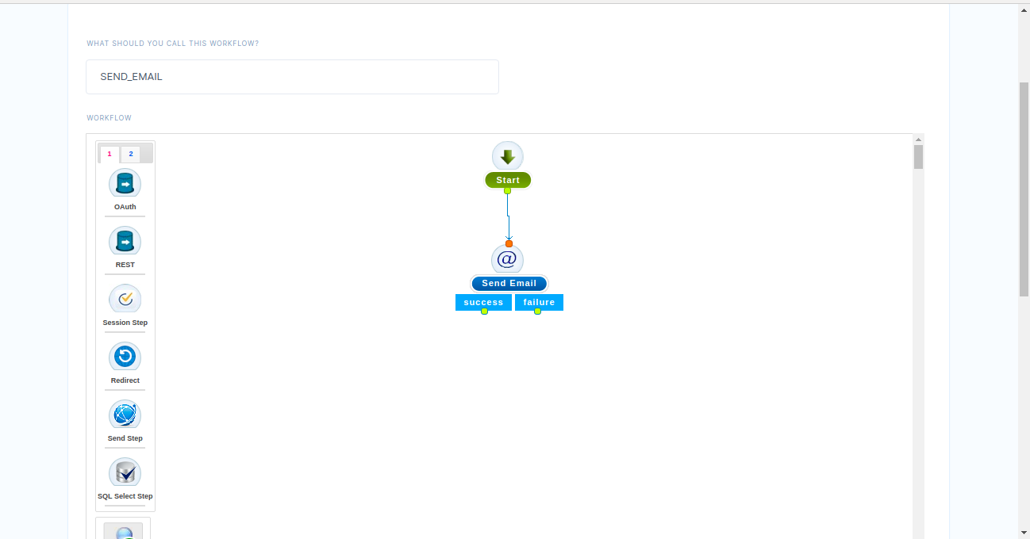

[**https://i.imgur.com/WdDJAS1.png**](https://i.imgur.com/WdDJAS1.png)

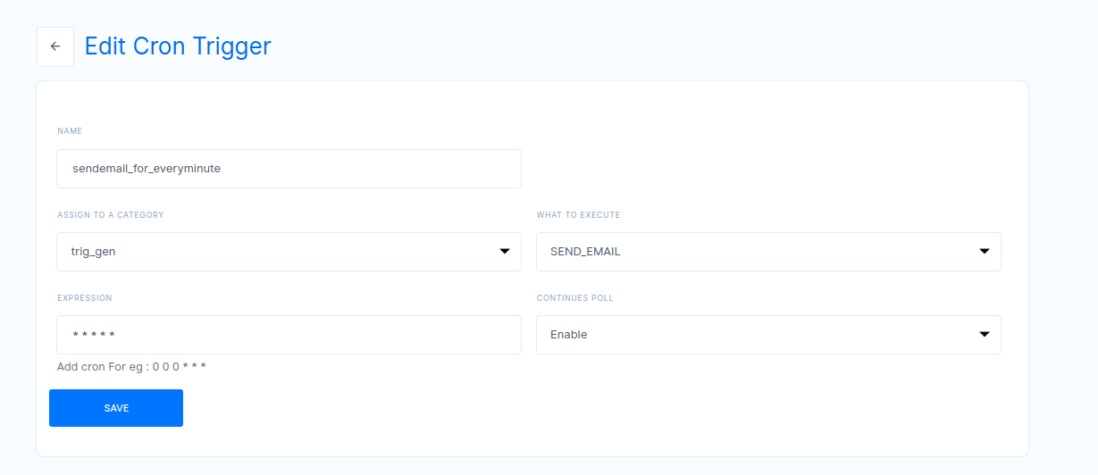

[**https://i.imgur.com/EbCXak4.png**](https://i.imgur.com/EbCXak4.png)

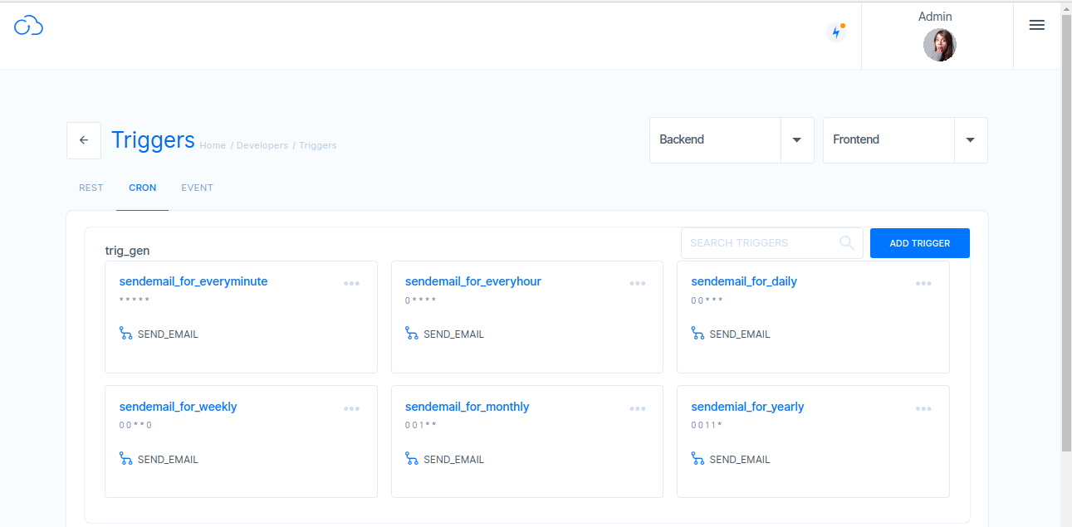

**Cron Frontend:**

Few pages were developed through which cron job data can be entered and saved fron frontend side.

Cron can be scheduled by adding the cron job data.

In schedule cron screen click on ‘Add Cron’. Enter the details that are required.

Provide the cron expression and cron job data.Format for cron job data is as follows:

Syntax:

{"args":"{}","headers":"{}","method":"POST","form":"{}","url":"RESTURL"}

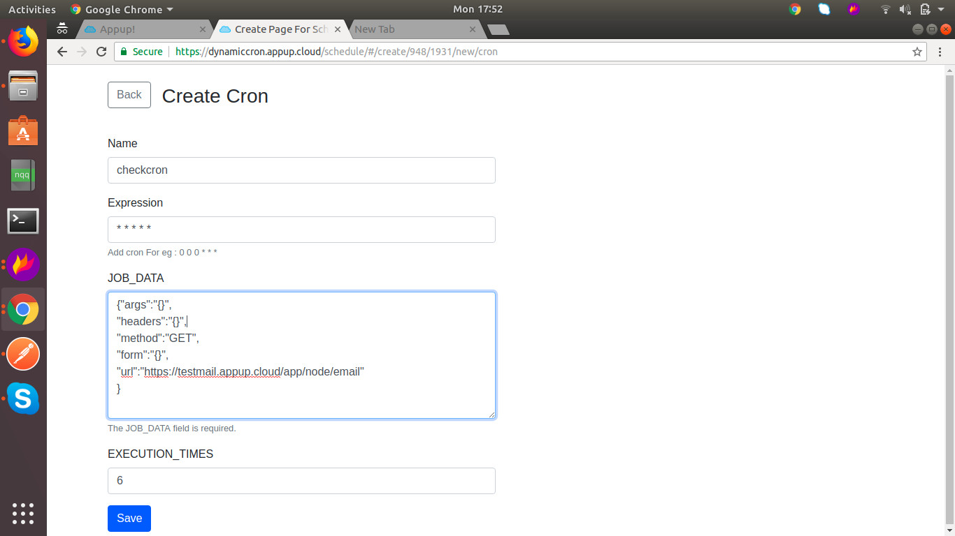

Different operations which we can perform are create cron,edit cron and delete cron.

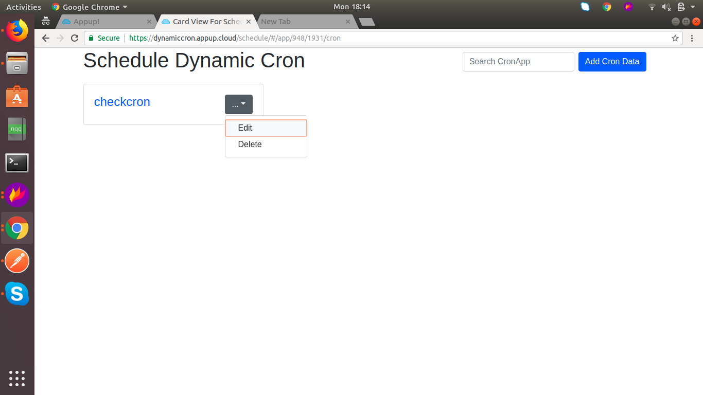

**Video Link:**

[**https://drive.google.com/file/d/1kQTlsh4lZrQ720HcetMxbuVuoDjOJWfP/view**](https://drive.google.com/file/d/1kQTlsh4lZrQ720HcetMxbuVuoDjOJWfP/view)

[**https://drive.google.com/file/d/1qPj5tVSSKmQ5wjzu-bMFcSz93qQ7a_ds/view**](https://drive.google.com/file/d/1qPj5tVSSKmQ5wjzu-bMFcSz93qQ7a_ds/view)